Query the names of all American cities in CITY with populations larger than 120000. The CountryCode for America is USA.

Input Format

The CITY table is described as follows:

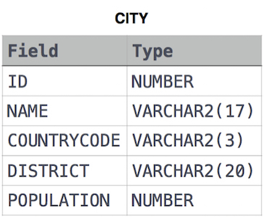

Solution:

SELECT NAME

FROM CITY

WHERE POPULATION >120000 AND COUNTRYCODE LIKE 'USA';